ROUTER INITIAL CONFIGURATION:
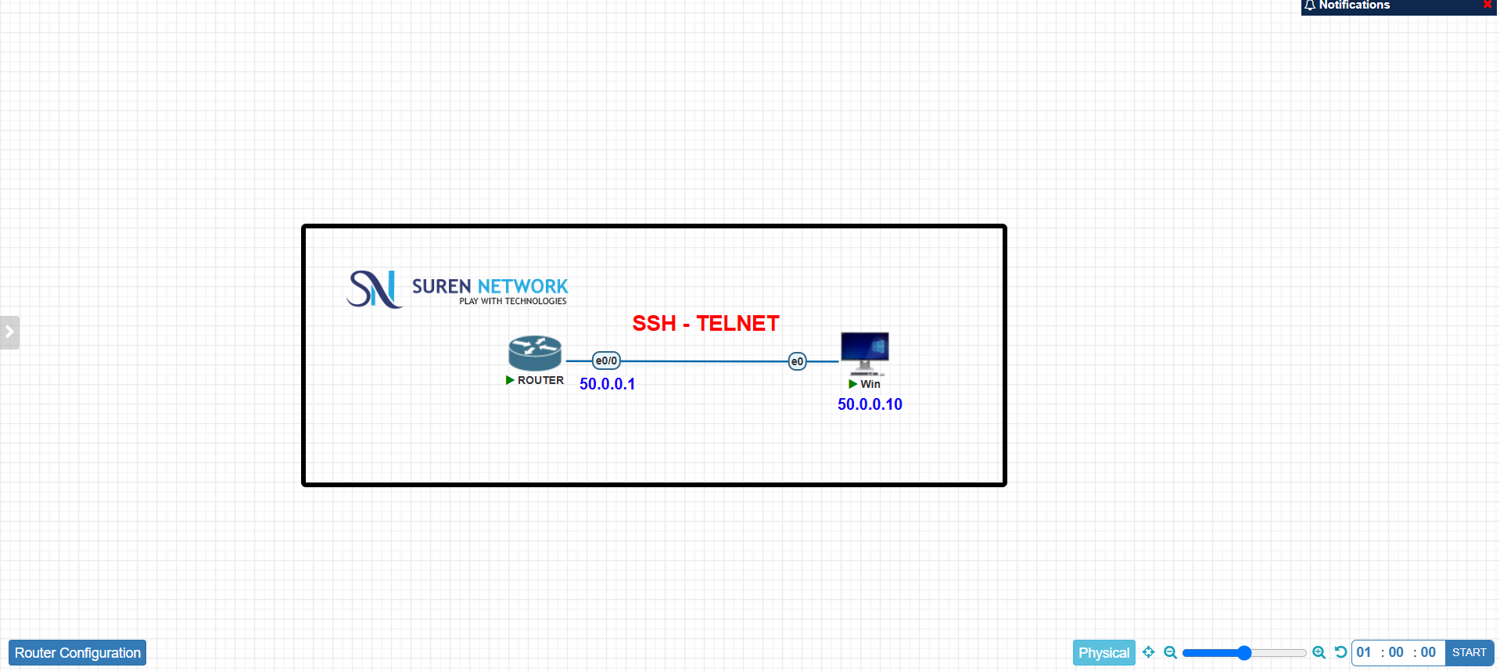
Step 1 : Assign ip address for Windows pc 50.0.0.10
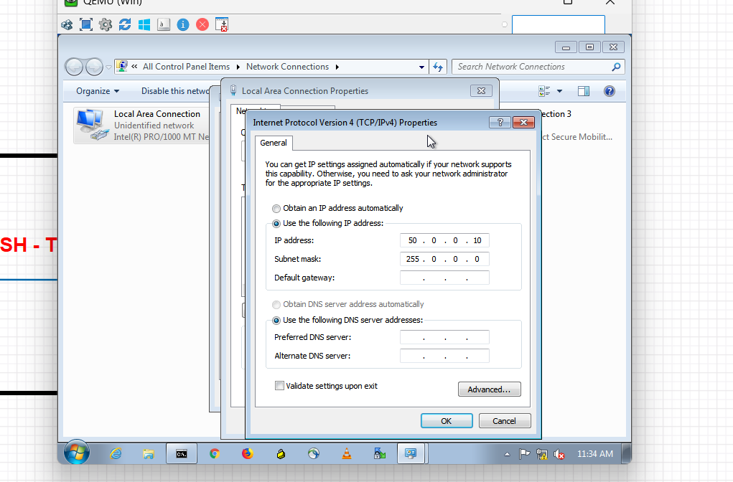
Step 2 : Assign ip address for router ethernet 0/0
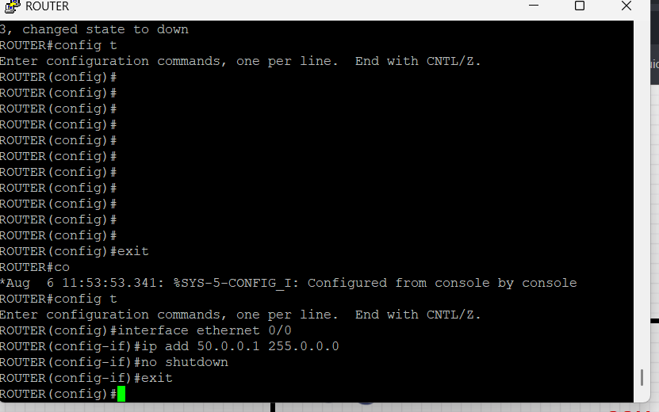
Step 3 : Tested the connectivity between the PC and the router. Both devices responded successfully to ping requests.
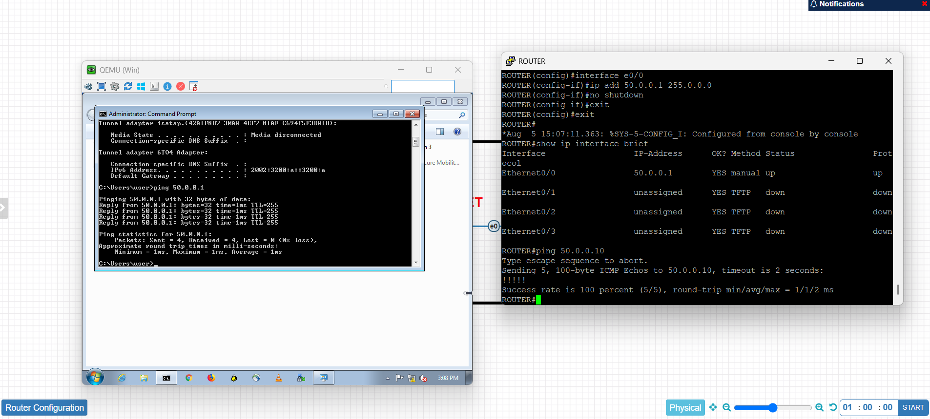
Step 3:Create console authentication for asking username and password.
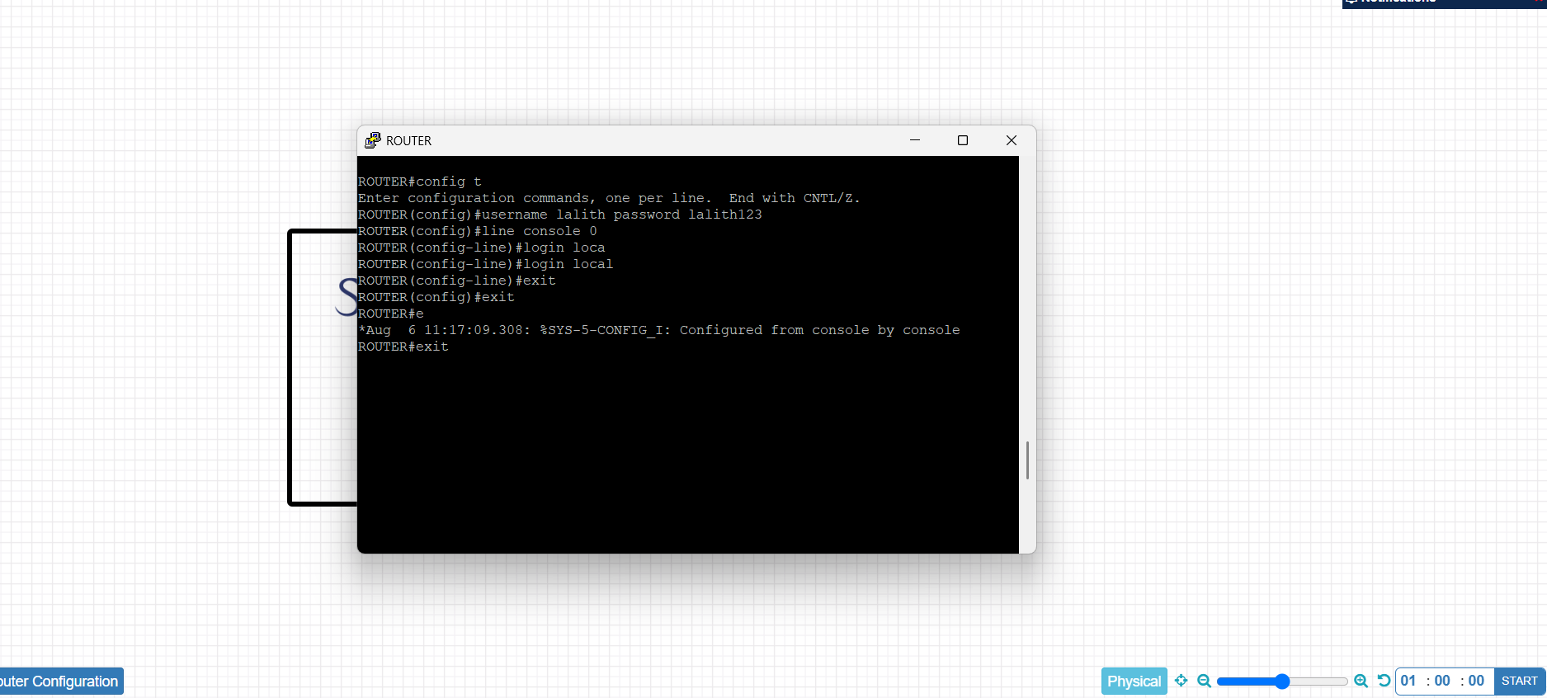

Step 4: created console authentication for asking password only.
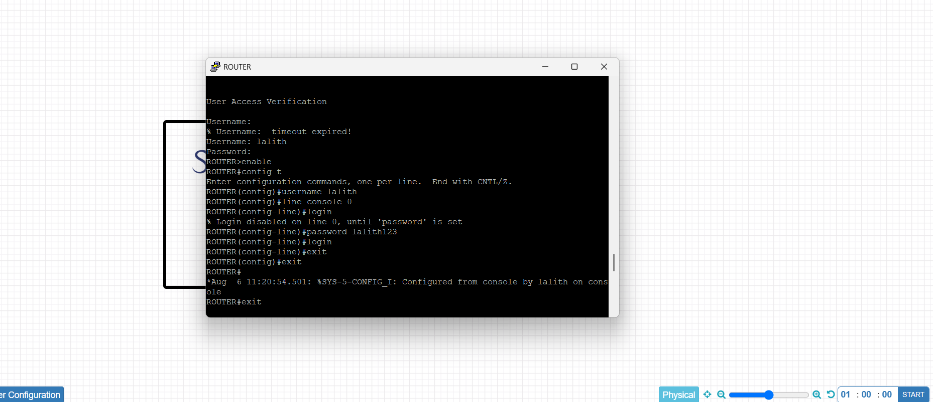
Step 5: Configured Telnet access on the router and verified remote connectivity by connecting from a Windows PC using the PuTTY application and the router's IP address.
